1) Write a script to find out String is palindrome or not.

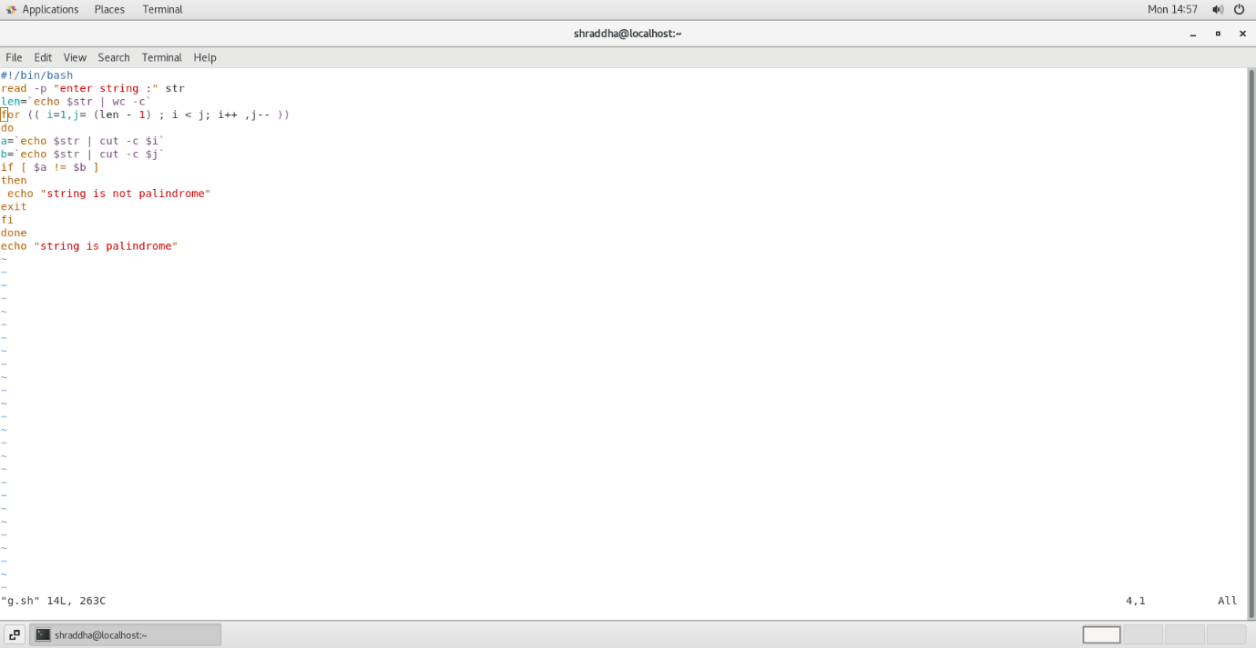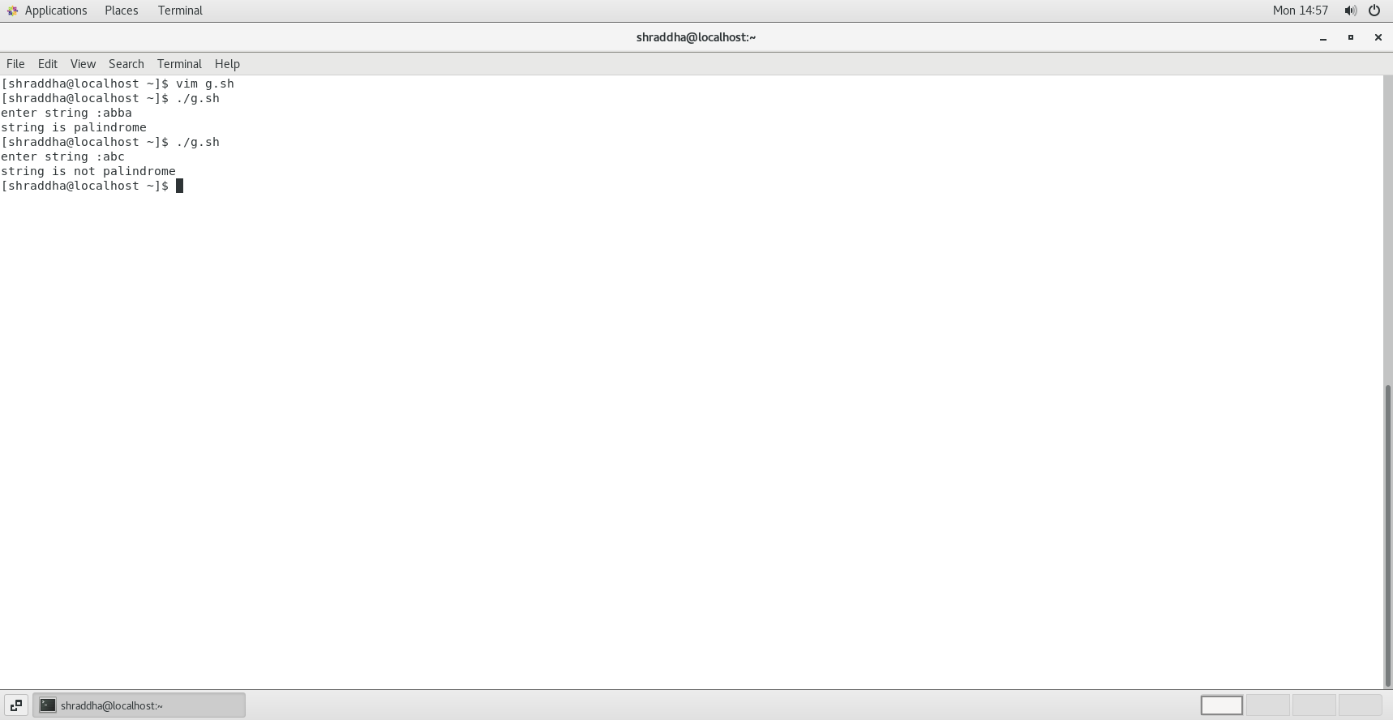

2) Write a shell script to accept 10 numbers and tell how many are +tive, -tive and zero.

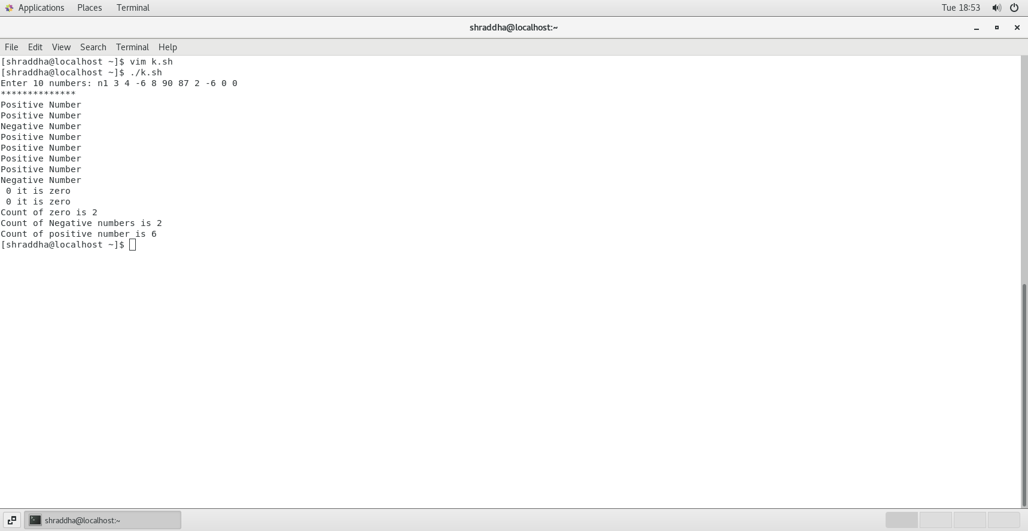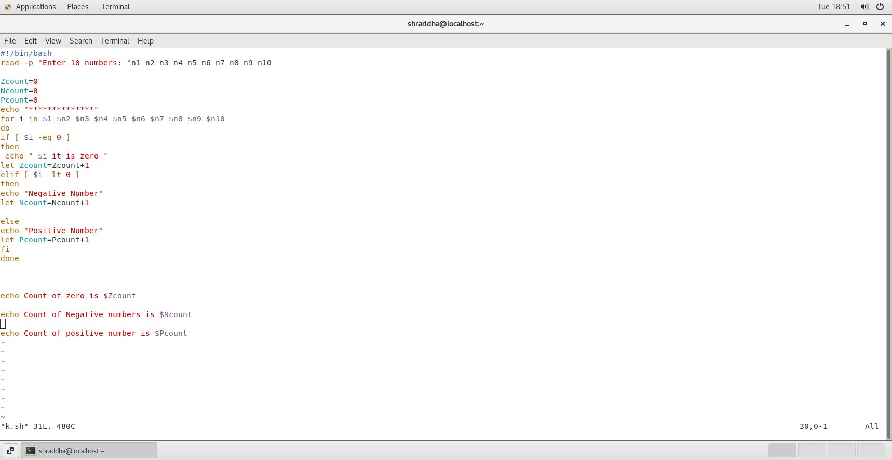

3) Write a shell script to print given number’s sum of all digits (eg. If number is 123, then it’s sum of all digits will be 1+2+3=6)

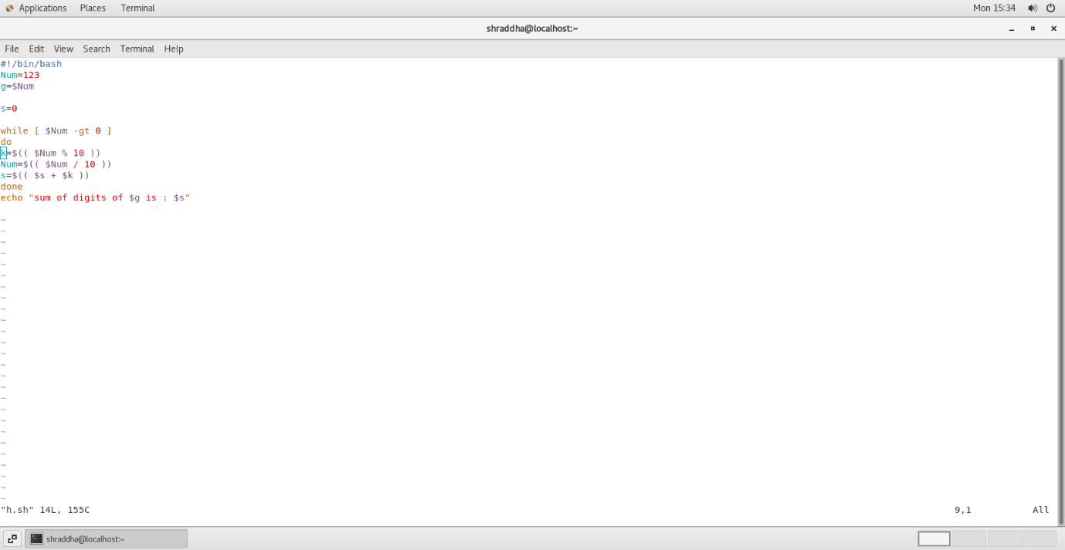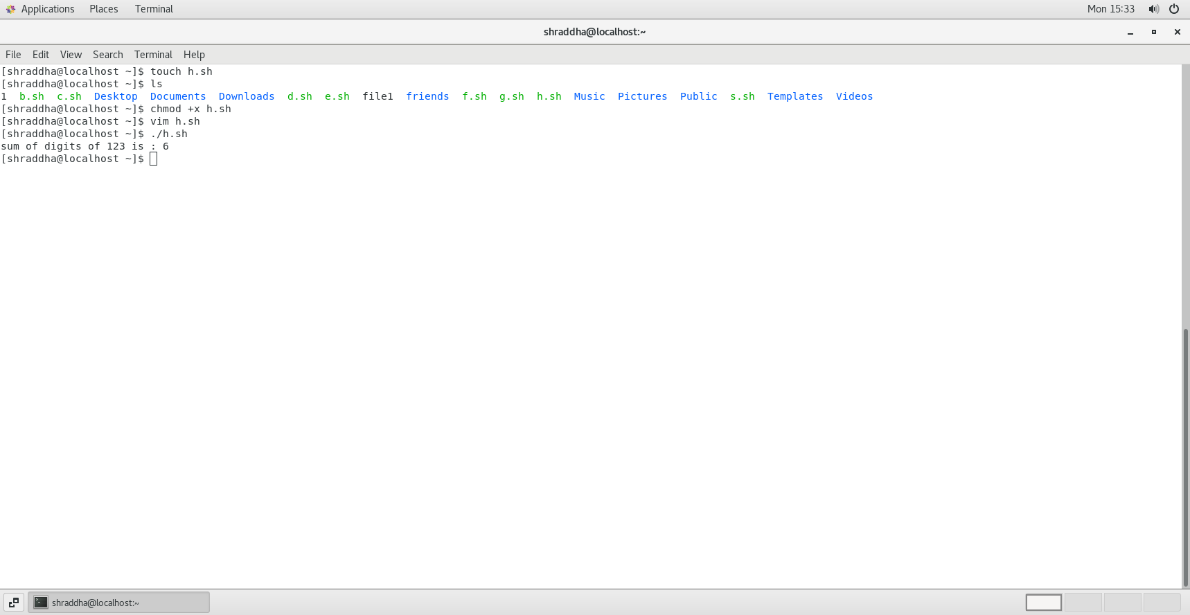

4)Write a shell script to display the prime numbers from 1 to n ( n is a given number )

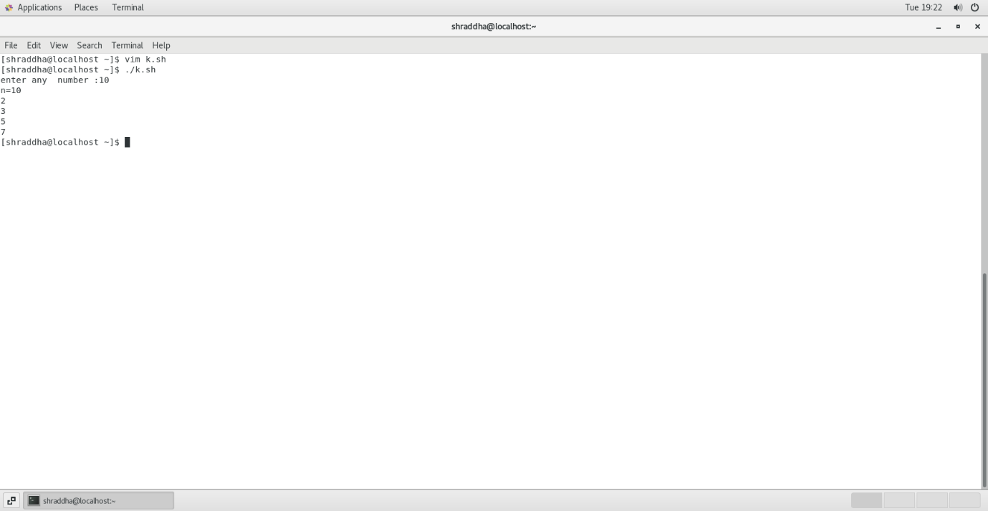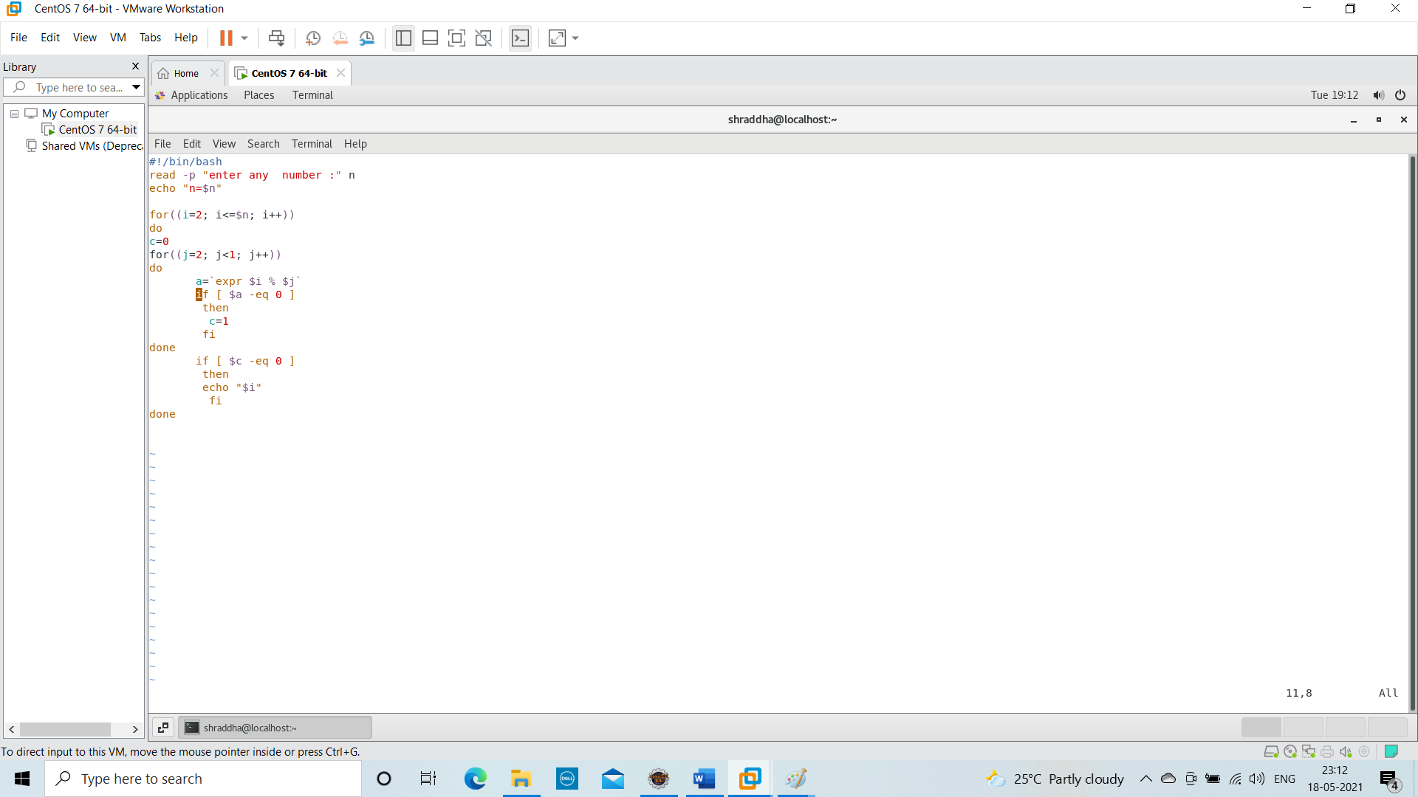

5) Write a shell script to find whether a given year is leap year or not

